NAME:: VAIBHAV KUMAR
REG NO:: RA1611003010669(CSE)

Centre Coordinates of BOUY

Given image to be processed and formulated.
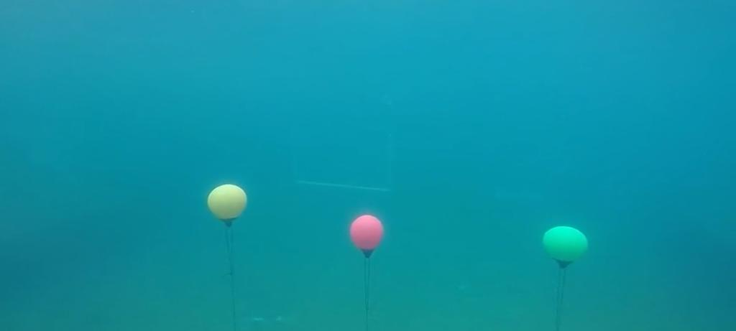

Objectives

1.To Compute the center of a contours mapping.
2.Apply a filter for noise reduction.
3.Label the centre of the contour detected.

Steps

1. 1st basic step is to take the input of the image using imread.

2. 2nd step to use a mean diagonising filter to apply a filter mask which will be a Mean
diagonising filter the output of which will be depend on predefined realationship.

3. Conversion of image to Grayscale (intenstity value 0-255)so that it is easy for the function to detect the vectors and not getting confused with the colours. If there will be only gray colour and easy thresholding segmentation the output will be much more easy to detect.

4. The next step is thresholding which will be used for segmentation of dark and light using or converting into binary.

5. Dilation of images for calculating the latitce of images.

6. Using the function cv2.findContours to find the places where the image has lattice points.

7. In a loop first all the contours will be first drawn in the orignal image, based on image moments which will help in identifying the shape of the contour and also in centre coordinates calculations later on.

8.Drawing the outline of the contour surrounding the current shape by making a call to
cv2.drawContours()

9.Placing a white circle at the center(cx,cy) coordinates of the shape.

10.Writing the text centre to indicate the centre of the buoy.

11.Using cv2.imshow() to show the image after being processed.

Output image::
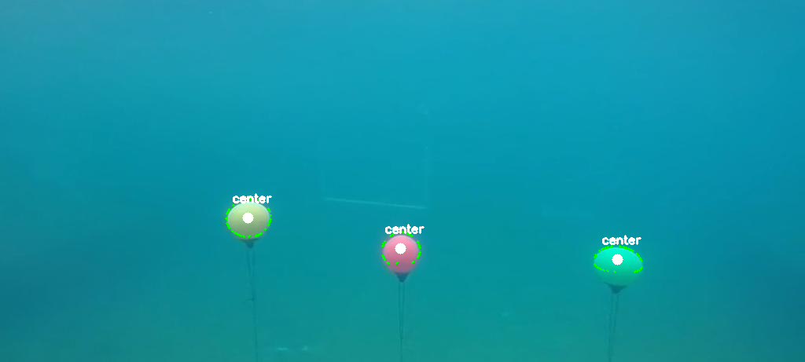

Problems Faced:

# Without using noise removal filter you will not be able to get proper contours since noise will create their own contours.
# The countours drawn due to noise will make its own centres since the centre here will be basically the centre of mass distribution over a plane or a closed body.
# The description of the such image without being removed noise is a follows.
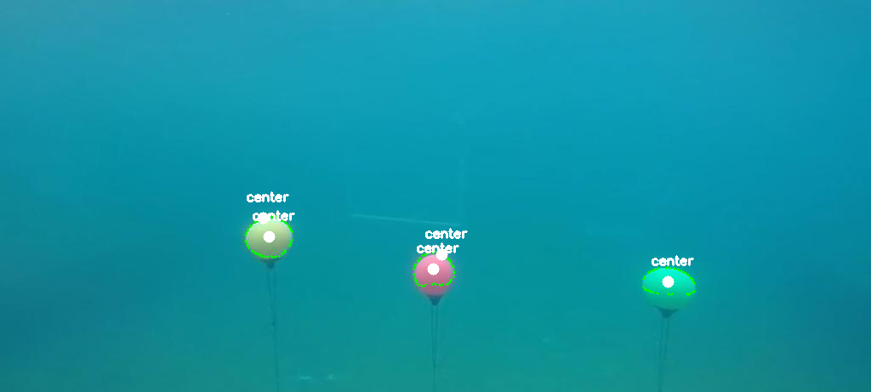

#As it can be seen the centre coordinates of the buoys are not properly marked and also the cv2 has detected some noise as contours and thus marking the centre of mass as centre of those noise

# So we need to remove the noise first using filters and then apply Dilation.

TASK 2
Suppose you are receiving a double from a sensor every 0.1s. Design an efficient storage
Algorithm for saving the most recent 64 samples using a constant sized buffer.

1. Since a constant sized buffer is required you can implement either in dynamic array of linked list so that there is no underflow or overflow of data in storage unit and since its also dynamic.
2. I used a linked list approach having a “double data” for storing a double data type in the linked list.
3. Once the data is being stored it will be inserted at the end of the list and so on just like an array data type.
4. The data can be inserted at constant time deletion of data is very easy as compared to arrays where all the elements have to be rearranged.

TASK 3

“Heading Averager”: In many cases, it is useful to average a few readings from the AUV's
compass before proceeding. All headings are integers in the range 0 to 360. Write a heading
“averager” that accepts user input and returns an average heading when requested by the
user.

ASSUMPTION: taking the values to be the missing values in a column of a dataset for Machine learning analyis. The approach is to fill the empty spaces also referred to as ‘NaN’ with the average value of all other integer values in that data set.

1. use of sklearn.prepocessing Library of python.
2. we can fill the missing values in data set using Imputer() ,function of the sklearn.preprocessing library.
3. and object for the Imputer() class has to created .
imputer = Imputer(missing_data = ‘NaN’,strategy = ‘ mean’, axis= 0)
4. contraints required by the Imputer function.

(i) missing_value = ‘NaN’
(ii)strategy = ‘mean’
(iii)axis= 0 or 1 //based on the operations

// stragtegy can either be mean or meadian depening upon the condition required
// axis =0 for colums wise
// axis =1 for row wise

5. then use of .fit(X) function to compute the average of all the colum wise data.
6. then we will fit the average calculated in the spaces where the data is missing.

X[/*required portion*/]=imputer.fit(X[//required portion])

7. After implententing these lines of code your missing data will be filled with the average of the pre-existing data and the missing_data will be filled.

